**# This is main page of project**

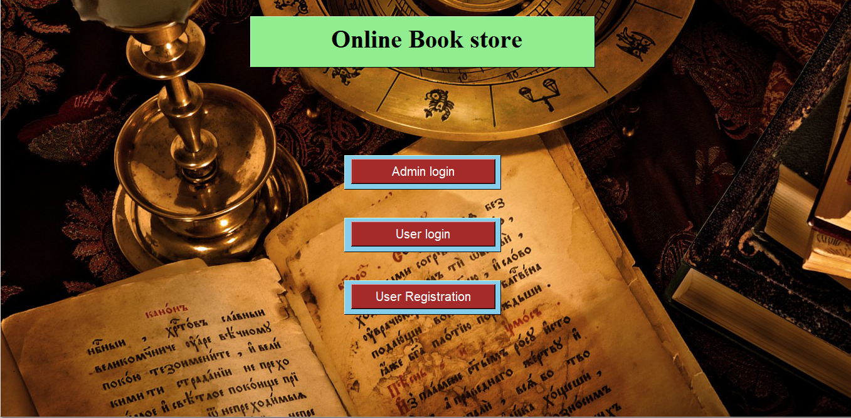

**# When we click on Admin login button Admin login page opens**

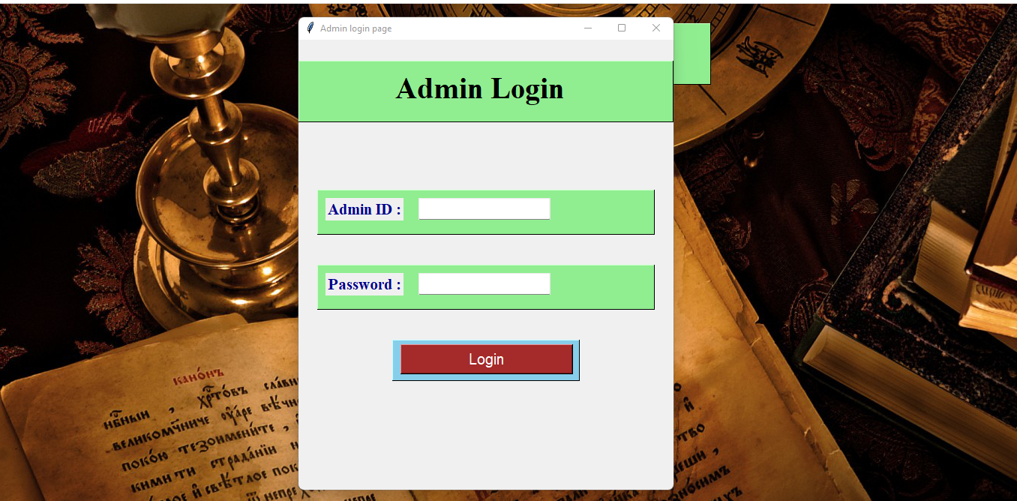

**# Then Enter Admin Id and password**

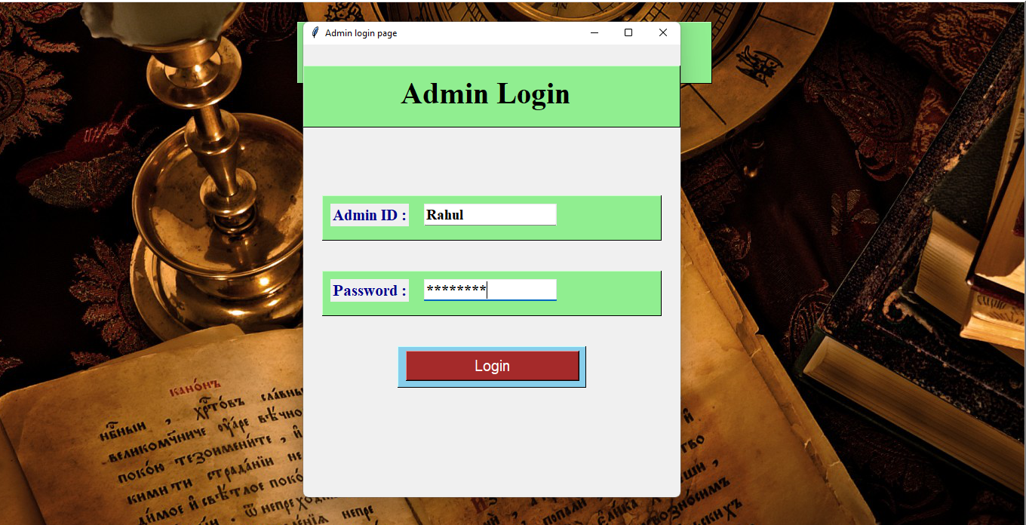

**# If invalid Admin ID or password is ID we get a error message**

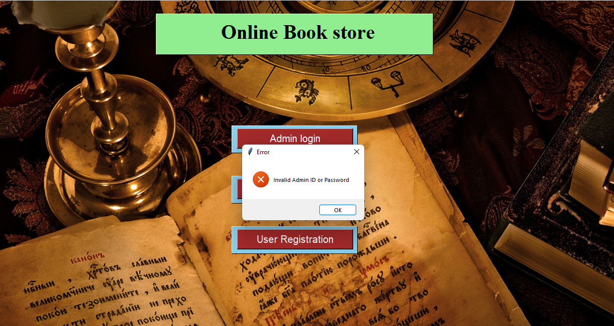

**# When correct Admin Id password Admin page opens**

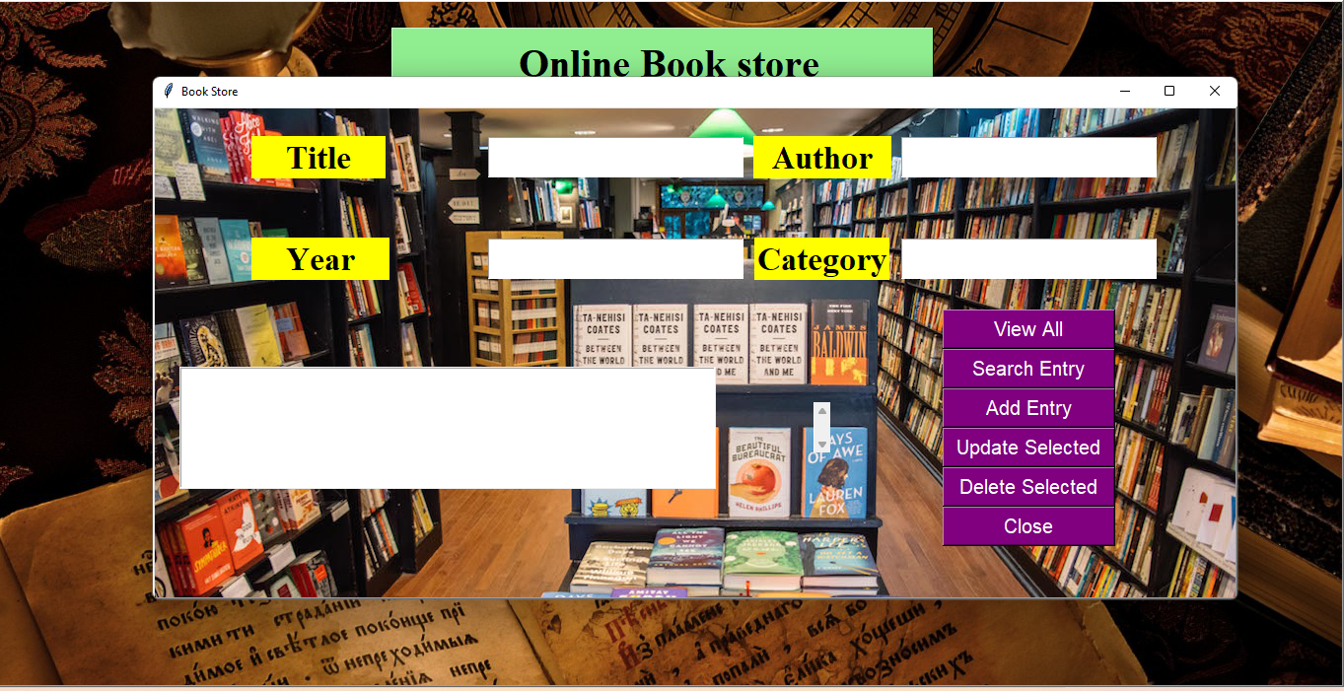

**# Above is Admin page**

Here we can add, update or delete books

**# When clicked on user login button on main page user login page opens**

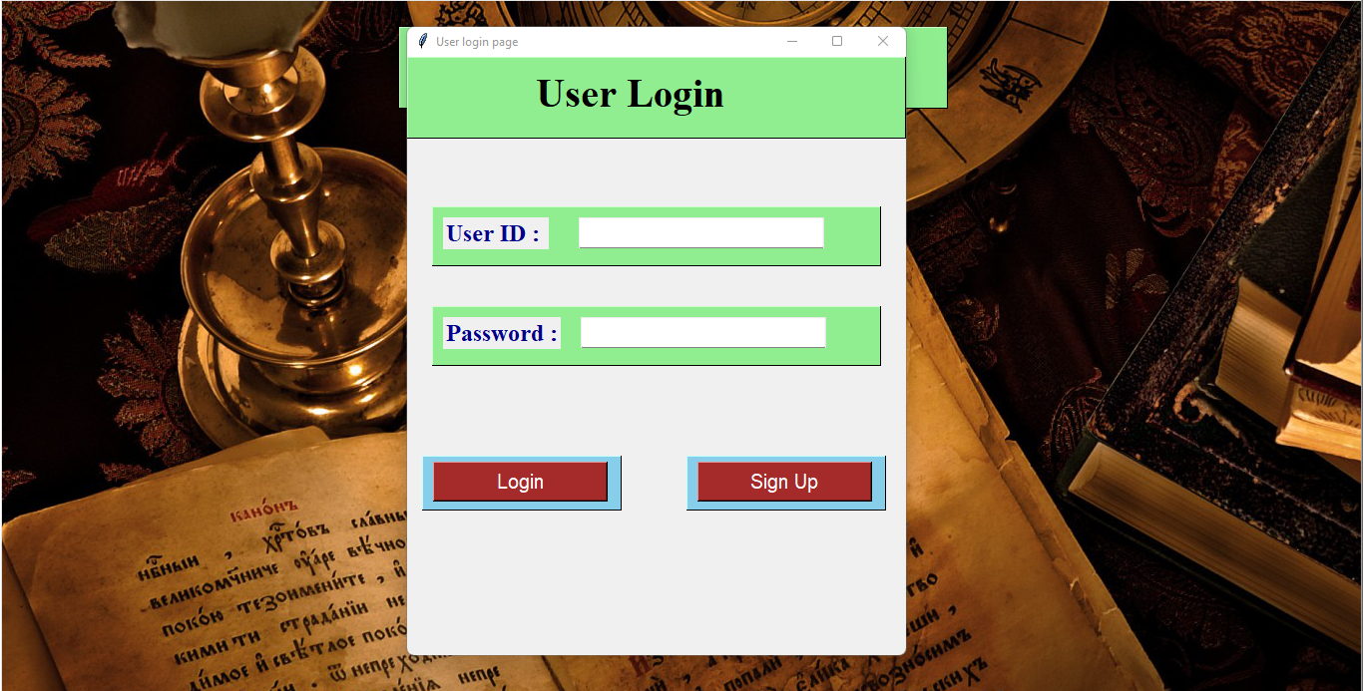

**# Enter User ID and password**

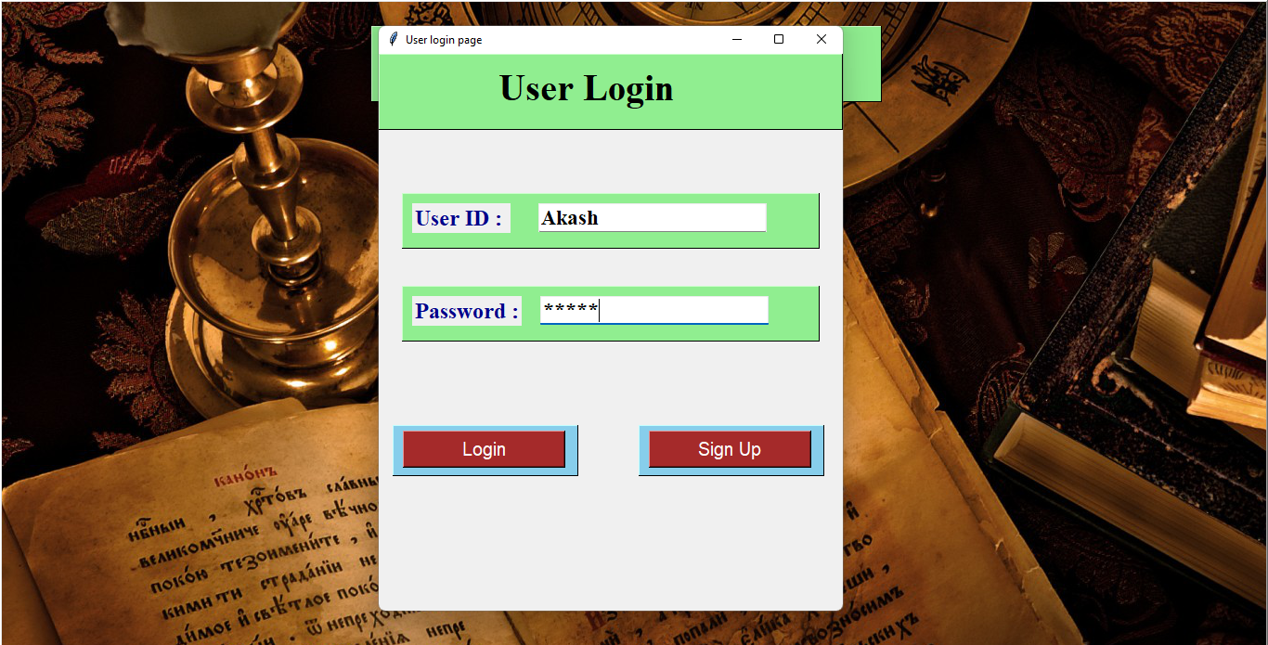

**# If invalid User Id or Password is entered we get error message**

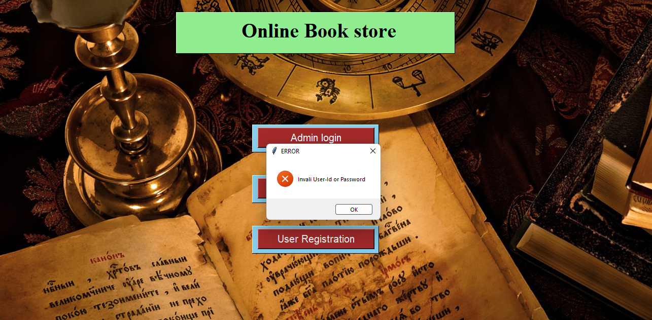

**# If you don’t have registered user Id password click on sign in button on user login page or click on User registration button on main page**

**Then user registration page opens.**

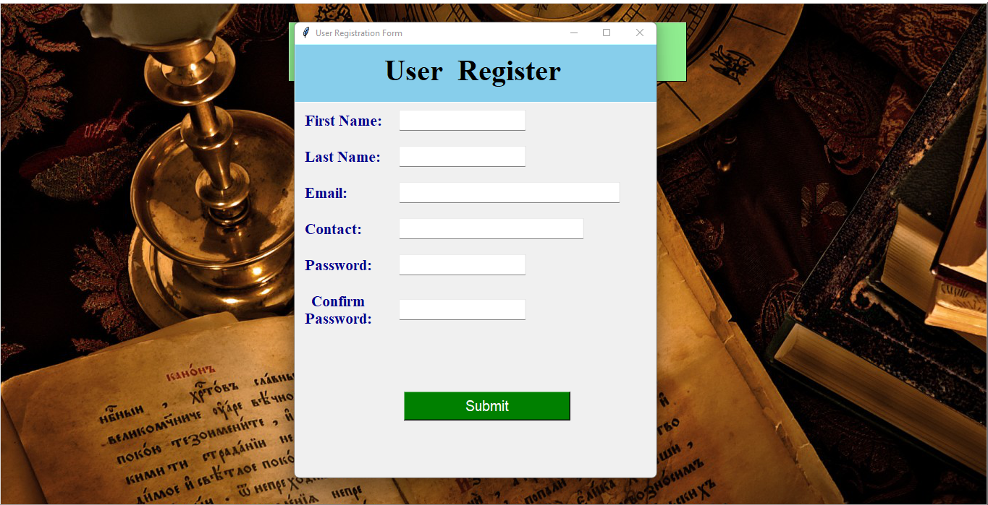

**# If a field is left blank we get error message**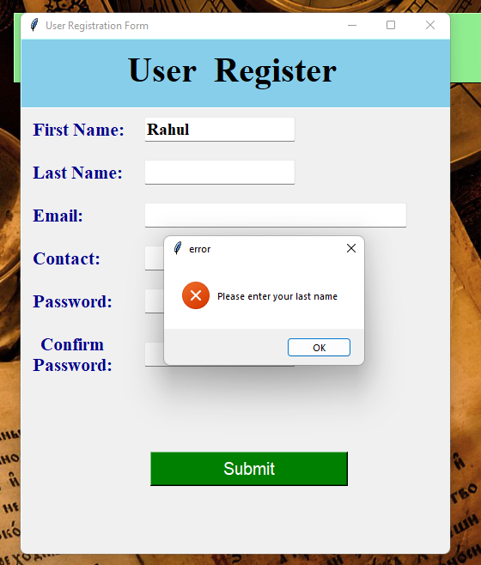

**# If password and Confirm password not matched we get error message**

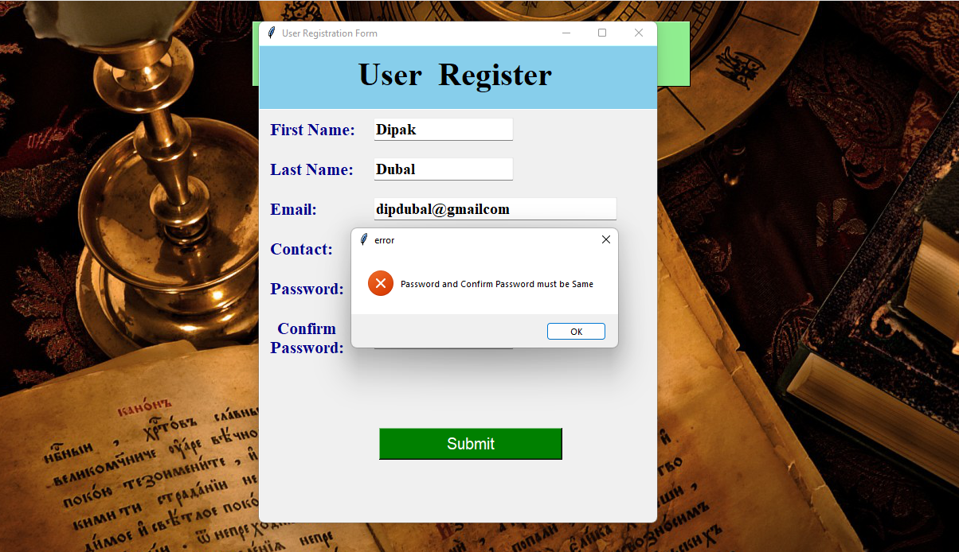

**# If all the fields are filled properly then user gets Confirmation message with User Id and password**

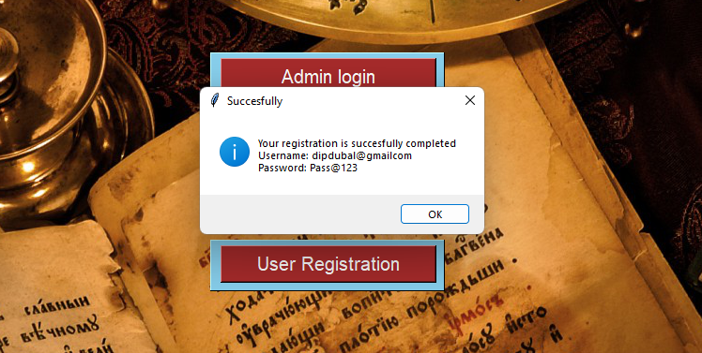

**# All the user information is stored in postgres database**

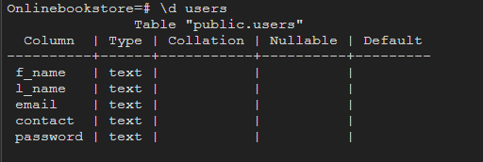

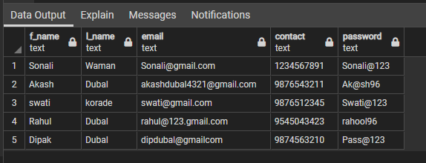

**# When correct user Id and password is entered User page opens**

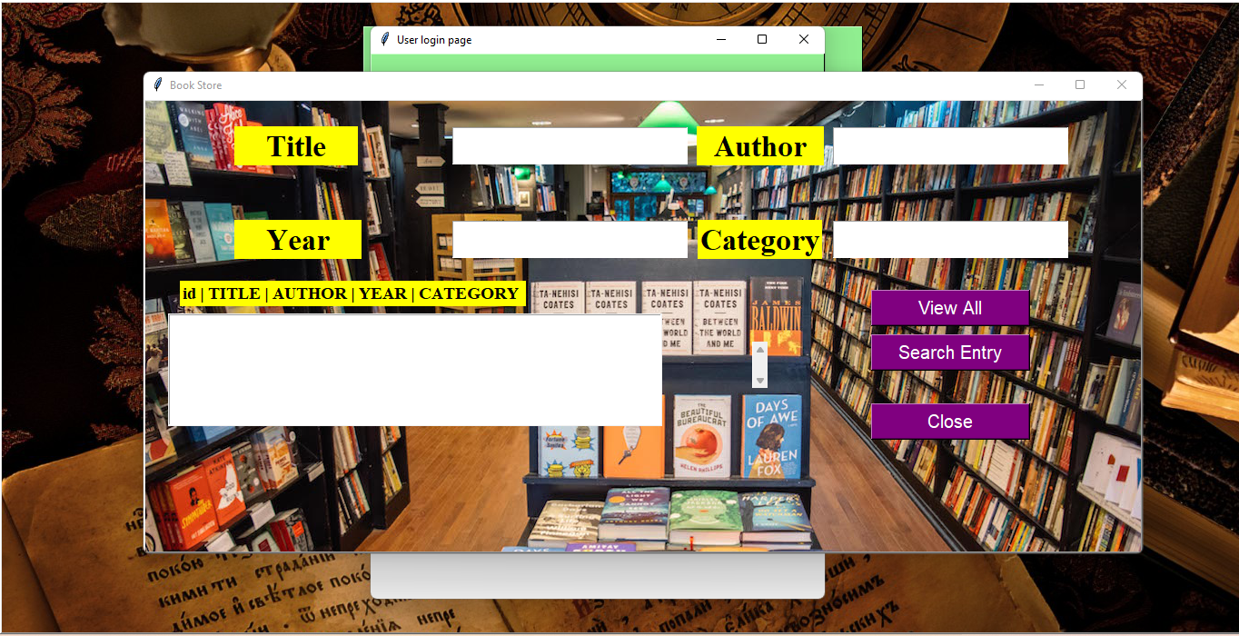

**# When user click View all button all the books are displayed in the list box**

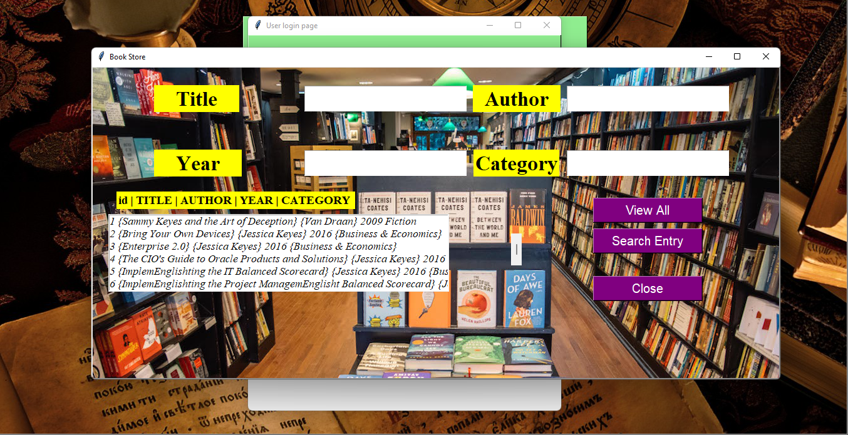

**Here we can search by Title, Author, Year, or by Category**